
QuickFix App — User Guide
Repair, upgrade, buy back and revive your tech

By Causal fun

Contents
1. Welcome 2
Who are we 2
What you need before you start 2
How to use this guide 2
2. Installing the app 3
Will it run on my phone? 3
Getting the app 3
If it will not install 3
Updates 3
3. Creating an account and signing in 3
Option A — Continue with Google 3
Option B — Email and password 4
Password rules 4
Where your password is kept 4
Sign in again later 4
Signing out 4
Forgotten password 4
4. Finding your way around 4
5. Booking a repair 5
Filling in the form 5
Where to find your model or serial number 5
Writing a good description 6
If something is wrong on the form 6
After you submit 6
Before you bring the device in 6
6. Tracking your repair 7
What you get back 7
What each status means 7
Why a status might not move 7
"We could not find a repair with those details" 7
7. Checking prices 8
Why some prices say "From" 8
Why your quote may differ 8
Free diagnostics 8
Prices change 8
8. Selling, trading in or buying pre-owned 8
Selling us your old device 8
What we look at 9
What to bring 9
Buying a pre-owned device 9
Trade in against repair 9
9. Changing your settings 9
A note on turning off email notifications 10
These settings stay on this phone 10
10. Getting help inside the app 10
11. Troubleshooting 11
Signing in and registering 11
Booking a repair 11
Connection and server 12
Tracking and pricing 12
The app itself 12
Still stuck 13
12. Your privacy and your data 13
What we collect 13
Your password, specifically 13
Who sees your information 14
Your rights under POPIA 14
Data on your device during a repair 14
13. Contacting QuickFix 14
Opening hours 14
Have this ready when you call 15
Which channel for what 15
14. Glossary 15
15. Appendix — for QuickFix staff 16
1. Bookings carry a reference and a customer 16
2. Six statues, not three 16
3. Status notes are read by the customer 16
4. Prices are live in two places 17
A note on pricing enquiries 17
16. Devops Boards 18

1. Welcome
The QuickFix app lets you book a laptop or phone repair, track it while we work on it, and check our prices, without having to phone the shop or walk in first.
You can use it to:
- Book a repair and get a reference number straight away
- See exactly where your device is in the repair process
- Check what a repair is likely to cost, in rands, before you commit
- Ask us about selling your old device or buying a tested pre-owned one
- Choose how we contact you

Who are we
QuickFix Laptop Solutions repairs laptops and phones for students, working professionals and small businesses around Pretoria.
Address | 296 Pretorius Street, Pretoria Central, Gauteng
Phone | +27 62 161 4699
Email | support@quickfix.co.za
Open | Monday to Friday 08:00–18:00, Saturday 09:00–13:00
Closed | Sundays and public holidays

What you need before you start
- An Android phone running Android 8.0 or newer
- An internet connection, either mobile data or Wi-Fi
- An email address, or a Google account if you would rather not create a password
That is all. You do not need to bring your device in to book, and there is no charge for a diagnostic assessment when you book the repair with us.

How to use this guide
If you just want to book a repair, read sections 3 and 5. If something has gone wrong, go straight to section 11, Troubleshooting. Everything else is here when you need it.

2. Installing the app

Will it run on my phone?
The app needs Android 8.0 (Oreo) or newer. To check: open Settings, tap About phone, and look for Android version. Almost every phone sold since 2018 qualifies.
There is no iPhone version yet. iPhone owners can use the website at quickfix.co.za, which does everything the app does except tracking.

Getting the app
Ask us for the download link at the counter, by phone or by email, and we will send you the installation file.
- Tap the link we send you. The file downloads to your phone.
- Open the downloaded file. Android will ask whether to allow installs from this source.
- Tap Settings, switch on Allow from this source, then tap back.
- Tap Install, then Open.

If it will not install
What you see | What to do
"App not installed" | You may already have an older copy. Uninstall QuickFix first, then install again
"Blocked by Play Protect" | Tap More details, then install anyway. The app is not yet listed on the Play Store, so Android treats it as unknown
"There was a problem parsing the package" | The download did not finish. Delete the file and download it again on a stable connection
Nothing happens when you tap the file | Open your Files app, go to Downloads, and tap the file from there

Updates
When we release a new version, we will send you a new link. Installing it over the old one keeps your account and your settings. You do not need to uninstall first.

3. Creating an account and signing in
You need an account so that your bookings stay attached to you and nobody else can look them up. There are two ways in.

Option A — Continue with Google
The quickest route. No password to invent and none to forget.
- On the sign-in screen, tap Continue with Google.
- Pick the Google account you want to use from the list your phone shows.
- That is it. You land on the home screen.

Option B — Email and password
- On the sign-in screen, tap New to QuickFix? Create an account.
- Fill in your full name, email address and password, then confirm the password.
- Tap Create account.
- Check your email for a verification message and tap the link in it.

Password rules
Your password must have:
- At least 8 characters
- At least one number
- At least one capital letter
- At least one lowercase letter
The app tells you which rule is not met as you type, so you are never guessing. A phrase with a number in it, such as Pretoria2Laptops, is both easy to remember and strong.

Where your password is kept
Not by us. When you create a password, it goes straight to Google Firebase Authentication over an encrypted connection and is stored there as a scrambled value that cannot be turned back into your password. QuickFix never sees it, never stores it and cannot tell you what it is if you ask.

Sign in again later
The app reminds you. Once you have signed in, opening the app takes you straight to Home. You will only see the sign-in screen again if you sign out or if you have not opened the app for a long time.

Signing out
Open the Settings tab and tap Sign out at the bottom. Do this if you lend your phone to someone or sell it.

Forgotten password
If you registered with Google, there is nothing to forget — just tap Continue with Google. If you register with an email and password, phone or email the shop and we will send you a reset link.

4. Finding your way around
Six tabs run along the bottom of the screen. Tapping between them never loses what you have typed, so you can check a price halfway through a booking and come back to it.
Tab | What it is for
Home | Your starting point. Shortcuts to book, track and check prices, plus our address and opening hours
Book | The repair booking form
Track | Look up a repair and see where it is
Pricing | What each repair costs by category
Settings | Dark mode, how we contact you, and sign out
Help | Answers to the ten questions we are asked most
The Home tab greets you by name once you are signed in. Below the three buttons you will find our address and hours, so you do not have to go hunting for them when you are on your way over.

5. Booking a repair
Open the Book tab. The whole form is on one screen; scroll down as you go.

Filling in the form
Field | What to enter | Notes
Full name | Your name as we should greet you | Letters, spaces, apostrophes and hyphens are all fine
Phone number | The number we should call | Any of 082 123 4567, +27 82 123 4567 or 0821234567 works
Email address | Where your confirmation goes | Check it carefully; a typo here means no confirmation
Device brand | Dell, HP, Lenovo, Apple, Asus, Acer, Samsung | Whatever is printed on the lid
Device model or serial | For example, XPS 15 9500 | See below for where to find it
Primary issue | Tap one of the seven options | Pick the closest match; the description does the rest
Describe the problem | At least 20 characters | This is the field that matters most

Where to find your model or serial number
- Laptop: turn it over. There is a sticker with the model and a serial or service tag on it
- Dell: look for "Service Tag", seven characters
- HP: look for "Product" and "Serial"
- MacBook: click the Apple menu, then About This Mac
- If the sticker has worn off: type what you do know, such as 15-inch HP, silver, about 3 years old. We will identify it when you bring it in
The more exact this is, the more exact your quote will be. Laptop parts vary enormously between models that look identical.

Writing a good description
We ask for at least 20 characters because "broken" tells us nothing. The three things that help most are:
- What happened. Did it get dropped, spilled on, or did it just stop?
- What it does now. No power at all? Powers on but black screen? Works but slow?
- When it started. Suddenly, or gradually over weeks?
A weak description: "laptop not working properly"
A good description: "I knocked it off the desk on Friday and now the bottom half of the screen shows coloured lines. Everything else still works and I can hear it starting up normally."
The second one lets a technician guess the part before you arrive.

If something is wrong on the form
The app checks each field as you go. If something does not look right, the field turns red and a line underneath tells you exactly what it wants, for example Please describe the problem in at least 20 characters. Nothing is sent until every field is happy, and fixing the field clears the message straight away.
Your answers are never cleared. If the booking fails to send because you lost signal, everything you typed is still there when you try again.

After you submit
- A green message appears with your reference number, in the form QF-2026-00042.
- A confirmation email arrives with the same reference and a summary of what you told us.
- We review the booking, usually the same working day, and call or email you with a quote.
- Once you approve the quote, bring the device in or arrange collection.
Write the reference down. You need it to track the repair, and quoting it when you phone saves everyone time.

Before you bring the device in
- Back up anything you cannot lose. We take care, but any repair carries a risk, and some faults make data unrecoverable before we even start
- Bring the charger if you have it
- Remove any screen lock, or be ready to unlock the device for us to test it
- Take out SD cards and anything else personal

6. Tracking your repair
Open the Track tab, type your reference number, and tap Track.
If you cannot find the reference, type the phone number you booked with instead. The app will find your most recent repair.
You can only see repairs booked on your own account. This is deliberate: it means nobody can type a guessed reference and read your details.

What you get back
- Your reference and the device
- The current status
- The date you booked
- Every status change so far, with the date and any note the technician added

What each status means
Status | What is happening | Typical time
New | We have your booking. Nobody has called you yet | Within one working day
Contacted | We have assessed it and sent you a quote. We are waiting for your go-ahead | Until you reply
In Progress | You approved the quote and a technician is working on it | Same day to 3 days for common repairs
Ready for Pickup | Done and tested. It is waiting at the front desk | Come and fetch it
Resolved | Collected and the job is closed | —
Cancelled | The booking was cancelled, by you or by us | —

Why a status might not move
- Still New after a day? We may not have reached you. Check your spam folder and that the number on the booking is right
- Stuck on Contacted? We are waiting for you to approve the quote. Repairs do not start until you say yes
- In Progress for longer than expected? Usually a part on order. Phone us and we will tell you where it is

"We could not find a repair with those details"
Three common causes:
- The reference is mistyped. It is the letters QF, the year and five digits — QF-2026-00042
- You are signed in with a different account from the one you booked with
- The booking was made on the website or at the counter and is not linked to your app account. Phone us and we will link it

7. Checking prices
Open the Pricing tab. Four chips across the top switch between categories; tap one and the list underneath changes.
Category | What it covers
Screen Replacement | Cracked, black or flickering displays, including touch screens
Battery & Power | Batteries, charging ports, replacement chargers
SSD & RAM Upgrades | Faster drives, more memory, drive cloning
Motherboard & Logic | Dead boards, liquid damage, component-level repair
Every price is in rands, includes VAT and includes standard labor. Nothing is added at the counter that is not on this screen.

Why some prices say "From"
A price like From R3,500 means the work varies with the fault. Board-level repair is the clearest example: a failed power circuit and a failed graphics chip are both motherboard work, but they are not the same job.

Why your quote may differ
These are estimates, and honestly so. A 15.6-inch screen for one HP model costs a different amount from a 15.6-inch screen for another, because the panel, the connector and the bezel differ. The price list gets you to the right order of magnitude; the quote is exact.
To get a firm quote, give us your exact model or serial number when you book. That one detail is the difference between "somewhere around R2,000" and "R1,850, and we have the part".

Free diagnostics
Component-level diagnostics are listed at R0. If you book the repair with us the assessment costs nothing, whatever we find. If you decide not to go ahead, you still owe nothing.

Prices change
Laptop parts are imported and the rand moves. We review prices monthly. The app always shows the current list because it reads the same database the shop does, so what you see is what we will charge today.

8. Selling, trading in or buying pre-owned

Selling us your old device
We buy laptops and iPhones, working or not. A dead laptop still has a screen, a drive and memory in it.
How it works:
- Estimate. Tell us the make, model, storage and condition, and anything wrong with it. We come back with a guide price
- Inspection. Bring it in. We check it properly — that takes about twenty minutes
- Offer. We make a firm cash offer. You are free to say no
The estimate is a guide. The firm offer always follows a physical inspection, because battery health and hidden liquid damage do not show up in a description.

What we look at
Laptops | iPhones
Make, model and age | Model and storage
Screen condition | Battery health percentage
Battery runtime | Screen, original or replaced
Storage and memory | Network lock
Liquid damage | Activation lock / Find My
Charger included | Box and cable

What to bring
- The charger, if you still have it
- Proof the device is yours and is unlocked
- Your ID. We record it for responsible buy-back, as second-hand goods law requires
Sign out of your accounts first. On an iPhone, turn off Find My and sign out of iCloud. We cannot buy a device with an activation lock still on it, because it is unusable to anyone but you.

Buying a pre-owned device
Tell us the type of device, your budget in terms of any brand preference and what you will use it for, and we will match you against current stock. Everything we sell is tested first.
Be honest about the budget and the use. "R6,000, for university essays and browsing" gets you a better match than "as cheap as possible".

Trade in against repair
You do not have to take cash. The value of a device you sell us can go against a repair or an upgrade on another machine, which often turns a R4,000 repair into something much smaller. Ask at the counter.

9. Changing your settings
Open the Settings tab. There is no Save button — every change applies the moment you make it.
Setting | What it does | Default
Dark theme | Switches the whole app to a dark color scheme. Easier on the eyes at night and kinder to the battery on an OLED screen | Off
Email notifications | Whether we email you your booking confirmation and status updates | On
SMS notifications | Whether we text you when your device is ready | Off
Preferred contact method | Email, Phone call or WhatsApp. How we get hold of you about a quote | Email
Default device brand | Pre-fills the brand on the booking form. Useful if you bring in the same machine often | Empty
Sign out | Signs you out and returns to the sign-in screen | —

A note on turning off email notifications
If you switch email notifications off you will not get your booking confirmation, which contains your reference number. Leave it on until the repair is finished or write the reference down when it appears on screen.

These settings stay on this phone
They are saved on the device, not to your account. Install the app on a second phone and you start from the defaults again. Your bookings, on the other hand, follow your account wherever you sign in.

10. Getting help inside the app
The Help tab answers the ten questions our front desk is asked most. Tap a question and the answer unfolds underneath it; tap again to close it.
 | Question
1 | How do I book a repair?
2 | Where do I find my reference number?
3 | What do the repair statuses mean?
4 | Why does the app say my phone number is invalid?
5 | I forgot my password
6 | Is my data safe?
7 | How accurate is the pricing?
8 | How do I change my notification settings?
9 | Can I sell or trade my old device?
10 | Who do I contact for anything else?
The Help tab works without a connection, so it is there even when the rest of the app is not.
If your question is not on the list, section 11 of this guide covers error messages, and section 13 has our phone number and email.

11. Troubleshooting
Every message the app can show you, what causes it and what to do.

Signing in and registering
Message | Why | What to do
Incorrect email or password | The address or the password does not match | Check for a typo and for caps lock. Still stuck, phone us for a reset link
An account already exists for that email address | You registered before, possibly with Google | Tap Continue with Google, or sign in with the password you set
That password is too weak | Fewer than 8 characters, or missing a number or a capital | Follow the rules in section 3
Passwords do not match | The two password fields differ | Retype the confirmation carefully
That email address is not valid | Missing an @ or a domain | Check the address, for example name@gmail.com
Google sign-in was cancelled or no Google account is available | You dismissed the picker, or the phone has no Google account | Add a Google account in your phone's settings, or register with email and password
Your session has expired. Please sign in again | You have been signed in over an hour with no activity | Sign in again. Your bookings are untouched

Booking a repair
Message | Why | What to do
Please enter a valid 10-digit South African number | Too short, too long, or an unexpected country code | Use 082 123 4567 or +27 82 123 4567
Please describe the problem in at least 20 characters | The description is too short to be useful | Add what happened, what it does now, and when it started
Please select a primary issue | No issue chip tapped | Tap the closest of the seven options
Name may only contain letters, spaces, apostrophes and hyphens | Digits or symbols in the name field | Remove them. O'Brien and Smith-Jones are both fine
Please check the highlighted fields | The server rejected something the app let through | Look for the red fields and fix what they ask for

Connection and server
Message | Why | What to do
No connection. Check your data or Wi-Fi and try again | The phone is offline, or data is off for this app | Turn data or Wi-Fi on and tap the button again. Nothing you typed is lost
Something went wrong on our side. Please try again shortly | A fault with our server | Wait a few minutes and retry. If it keeps happening, phone us
Unexpected error. Please try again | Something we did not anticipate | Retry. If it repeats, tell us what you were doing so we can fix it
The service is temporarily unavailable | Our database is unreachable | This is on us. Phone the shop and we will take the booking by hand

Tracking and pricing
Message | Why | What to do
Enter a reference such as QF-2026-00042, or your phone number | The reference is not in the right shape | QF, the year, then five digits. Or type the phone number you booked with
We could not find a repair with those details on your account | Wrong reference, wrong account, or the booking was not made in the app | See section 6. If it was booked at the counter, phone us and we will link it
No pricing available for this category | That category has no living prices right now | Try another category, or phone us for a quote

The app itself
Symptom | What to do
Screen is blank or frozen | Close the app fully and reopen it. Nothing is lost
App closes unexpectedly | Reopen it and tell us what you were doing. That report is what lets us fix it
Everything looks wrong after an update | Sign out, close the app, reopen and sign in
Text is too small or too large | The app follows your phone's font size setting under Display

Still stuck
Phone +27 62 161 4699 during opening hours or email support@quickfix.co.za. Tell us what you tapped, what you expected and what happened instead — that is usually enough for us to sort it out on the first call.

12. Your privacy and your data
We handle your personal information under the Protection of Personal Information Act (POPIA), Act 4 of 2013.

What we collect
What | Why | Where it is kept
Your name | To greet you and label the job | QuickFix database
Email address | Confirmations and quotes | QuickFix database and the sign-in service
Phone number | To call you about the repair | QuickFix database
Device brand, model, fault | To quote and repair it | QuickFix database
Your password | To sign you in | Not with us. Held by Google Firebase Authentication, scrambled
App settings | To remember how you like the app | Your phone only
We do not collect your location, your contacts, your photos or anything else on your phone. The app asks for one permission: internet access.

Your password, specifically
When you create a password, it travels over an encrypted connection to Google Firebase Authentication and is stored there as a one-way scrambled value. There is no way back from that value to your password, which is why nobody at QuickFix can tell you what yours is like, we would have to reset it instead.
If our database were ever stolen, it would contain no customer passwords at all.

Who sees your information
Only QuickFix staff, and only to do the repair. We do not sell your details, share them with marketers, or pass them on to anyone else except where the law requires it — the ID record for second-hand purchases is the one example.

Your rights under POPIA
You may:
- Ask what personal information we hold about you
- Ask us to correct anything that is wrong
- Ask us to delete your information, where we are not required to keep it
- Object to how we are using it
- Complain to the Information Regulator if you are not satisfied with our answer
Email support@quickfix.co.za with any of these. We will reply within a reasonable time, and we will not charge you for a reasonable request.

Data on your device during a repair
Back up anything you cannot afford to lose before you hand the device over. Some faults, especially failed drives and liquid damage, can make data unrecoverable before we touch it. We will ask you to confirm you understand this when you bring the device in.
We do not browse the contents of your device. We only access what is necessary to test the repair.

13. Contacting QuickFix
Address | 296 Pretorius Street, Pretoria Central, Gauteng
Phone | +27 62 161 4699
Email | support@quickfix.co.za
Website | quickfix.co.za

Opening hours
Day | Hours
Monday to Friday | 08:00 – 18:00
Saturday | 09:00 – 13:00
Sunday and public holidays | Closed

Have this ready when you call
- Your reference number, if you have one
- The make and model of the device
- A one-line description of the fault
With those three things we can usually answer in a single call instead of phoning you back.

Which channel for what
You want to | Best route
Book a repair | The app, or the website
Check where your repair is | The Track tab
Approve or query a quote | Reply to our email, or phone
Ask about selling a device | Phone, or ask at the counter
Report a problem with the app | Email with the message you saw
Anything urgent | Phone. Email is not monitored after hours

14. Glossary
Term | What it means
Activation lock | An Apple feature that ties an iPhone to its owner's Apple ID. It must be off before we can buy the device
Battery health | How much of its original capacity does a battery still hold, as a percentage. Below about 80% is where you start noticing
Diagnostic | We do the assessment to find out what is wrong. Free when you book the repair with us
Motherboard | The main circuit board. Repairing one means working at the level of individual components
Pre-owned | Second-hand, tested by us before it is sold
RAM | Working memory. More of it is what stops a laptop crawling when you have several things open
Reference number | Your booking's unique code, in the form QF-2026-00042. Use it to track when you phone
Single sign-on (SSO) | Signing in with an account you already have, in our case Google, instead of creating a new password
SSD | A solid-state drive. The single biggest speed upgrade for an older laptop
Status | Where has your repair got to. The six values are explained in section 6
Trade-in | Selling us your old device, for cash or against a repair
VAT | Value-added tax, 15%, already included in every price the app shows

15. Appendix — for QuickFix staff
The admin panel works as it always has. Four things are different now that bookings also arrive from the app.

1. Bookings carry a reference and a customer
Every booking now has a reference on the form QF-2026-00042. Customers have it in their confirmation email and will quote it on the phone. Bookings made in the app are also linked to a signed-in customer, so their whole repair history is in one place.

2. Six statues, not three
Status | Set it when
New | Automatic on submission
Contacted | You have quoted the customer
In Progress | They approved and work has started
Ready for Pickup | Done, tested, at the front desk
Resolved | Collected and closed
Cancelled | Cancelled by either side

3. Status notes are read by the customer
This is the big change. When you change a status, the note you type appears in the customer's app, immediately, word for word.
Write this | Not this
"Replacement screen fitted and tested" | "Panel swap done"
"Waiting for the battery to arrive, expected Thursday" | "Part otw"
"Quote sent by email — R1,850" | "quoted"
"Liquid damage cleaned, testing the board now" | "Ultrasonic, board tbc"
Write as if the customer is standing in front of you, because in effect they are. No abbreviations, no internal shorthand, no blame.

4. Prices are live in two places
Editing a price in the admin panel changes it on the website and in the app, straight away. Before you change one, remember that someone may be looking at the old number on their phone. Where a quote has already gone out, honor the quoted price.

A note on pricing enquiries
Customers now arrive having seen the price list, so the question has shifted from "what does a screen cost?" to "why is mine more than the list says?". The honest answer is the right one: the list is an estimate because panels vary by model, and their exact quote comes from their exact model number.

16. Devops Boards
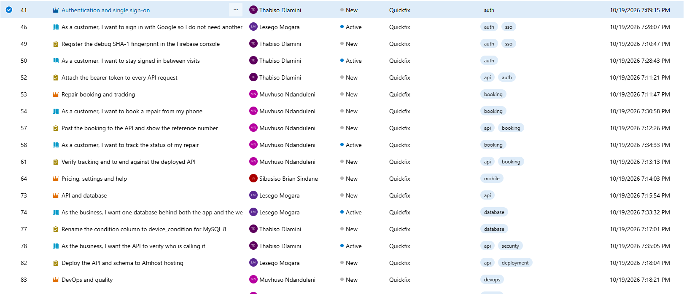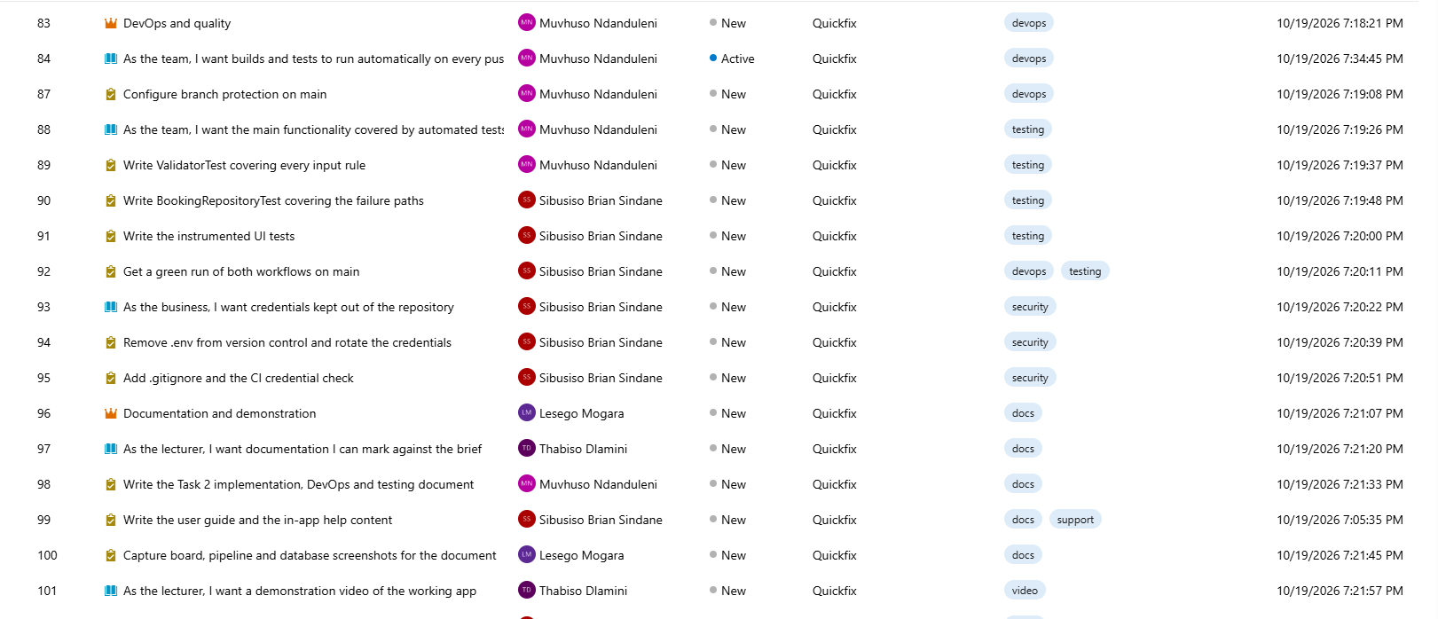

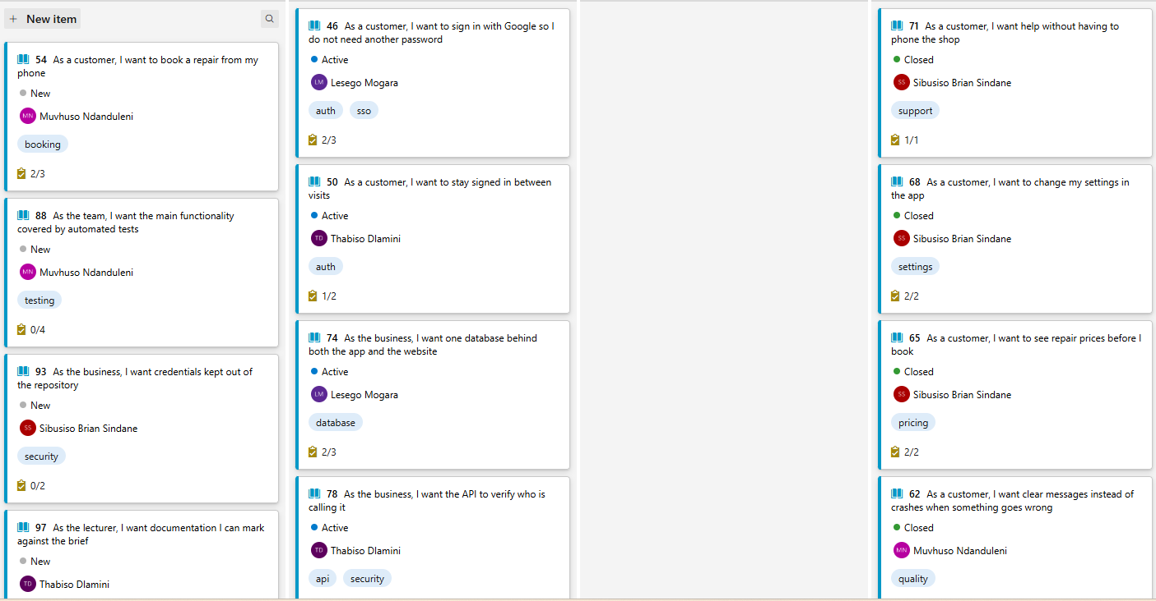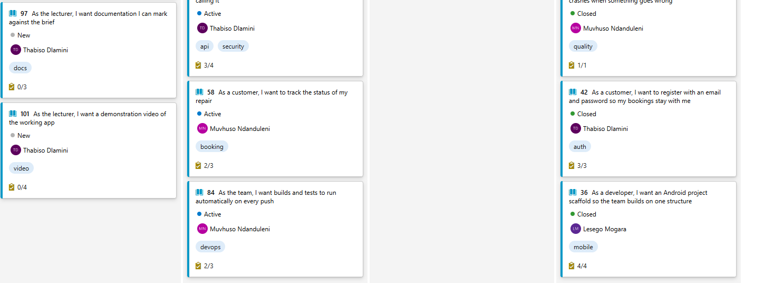

Links
- https://dev.azure.com/ST10456839/Quickfix/_boards/board/t/Quickfix%20Team/Stories
- https://github.com/ST10456839/QuickFix
- https://www.youtube.com/watch?v=flybWniIe58

